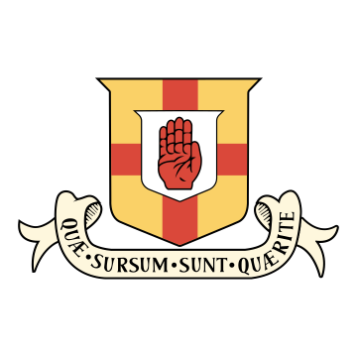

**School Meals**

|  |  |
| --- | --- |
| **Main Meal**  **(sides included)** | **£4.50** |
| **Sandwich** | **£3.50** |
| **Soup & Roll** | **£3.00** |
| **Soup & Sandwich** | **£4.50** |
| **Salad** | **£3.50** |
| **Dessert** | **£1.00** |